**Project 2 Proposal**

**DACA Visualizations**

**Teya Robinson, Matt Clewis, Margaret Ulrich, Sarah Sprole**

**TOPIC & GENERAL LAYOUT PLAN:**

We will use visualizations of age, sex, marital status, country of birth, and states of residence to explore the Deferred Action for Childhood Arrivals program. We will use maps to incorporate data showing states of residence, a bar chart showing country of origin, and pie charts for age, sex, and marital status.

**DATASETS:**

<https://www.kaggle.com/anupamakhan/daca-recipients-as-of-sept-4-2017>

Located in GitHub Repo:

Age.csv, Sex.csv, Marital_Status.csv, CBSA.csv, Country_of_Birth.csv, State_Of_Residence.csv

**SCREENSHOTS OF INSPIRING VISUALIZATIONS:**

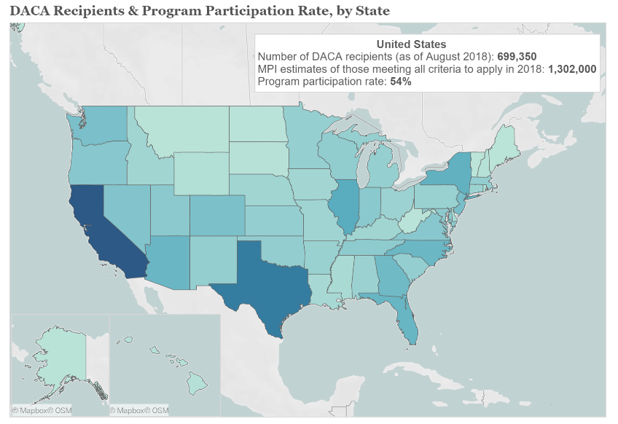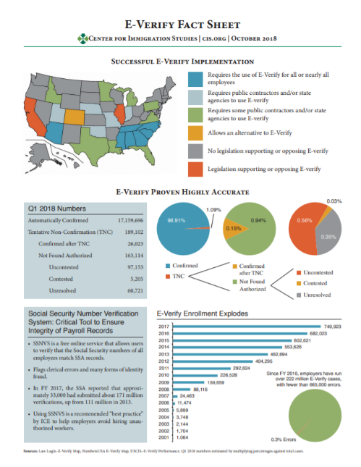

**GITHUB REPO:**

<https://github.com/teyarobinson/DACA>